Report

Mohamed Megahed

01016290044

Project Part 2

Spectrum Analyzer

Contents

Introduction 2

Manual 3

Results, and Example 9

References 13

# Introduction

Spectrum Analyzer v0.1 is signal processing software based on MATLAB. It does support very necessary features for signal processing

**Supported Features:**

• Time and Frequency domain analysis.

• Discrete time convolution.

• Windowing effect.

• Comparison mode.

• Calculation mode. (Part 2)

• RMS averaging. (Part 2)

• Peak finding. (Part 2)

• Bias finding. (Part 2)

• Different display options. (Part 2)

• Markers. (Part 2)

• Frequency band choices. (Part 2)

• Different input options. (Part 2)

• FIR filter design using least square method. (Part 2)

# Manual

**Starting Window**

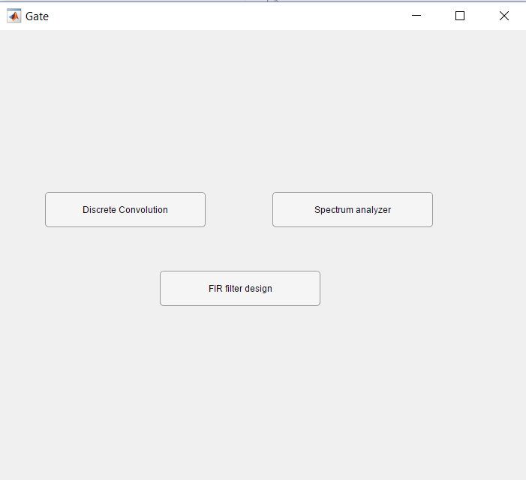

3

1

2

1

This Window allows the user to navigate through the two main windows of the Software

1- this button leads to Discrete Convolution window

2- this button leads to Spectrum analyzer window

3- this button leads to Filter Design window

**Discrete Convolution Window**

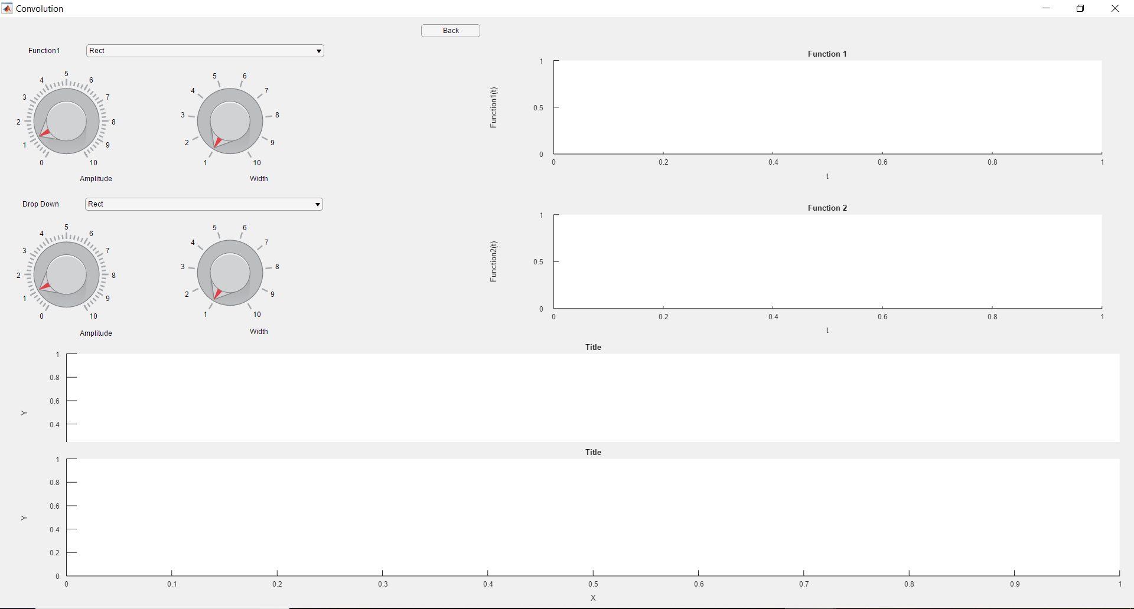

11

10

9

8

7

6

5

4

2

1

3

1. First function selection drop menu
2. First function amplitude control knop
3. First function Width control knop
4. Second function selection drop menu
5. Second function amplitude control knop
6. Second function Width control knop
7. First function graph representation
8. Second function graph representation
9. Convolution graph representation
10. Animated Convolution graph representation
11. Back button: takes you back to the opening window

**Scale selection was implemented**

|  |
| --- |
|  |
|  |

**Spectrum Analyzer Window**

This window has 2 tabs

Spectrum Analyzer tab

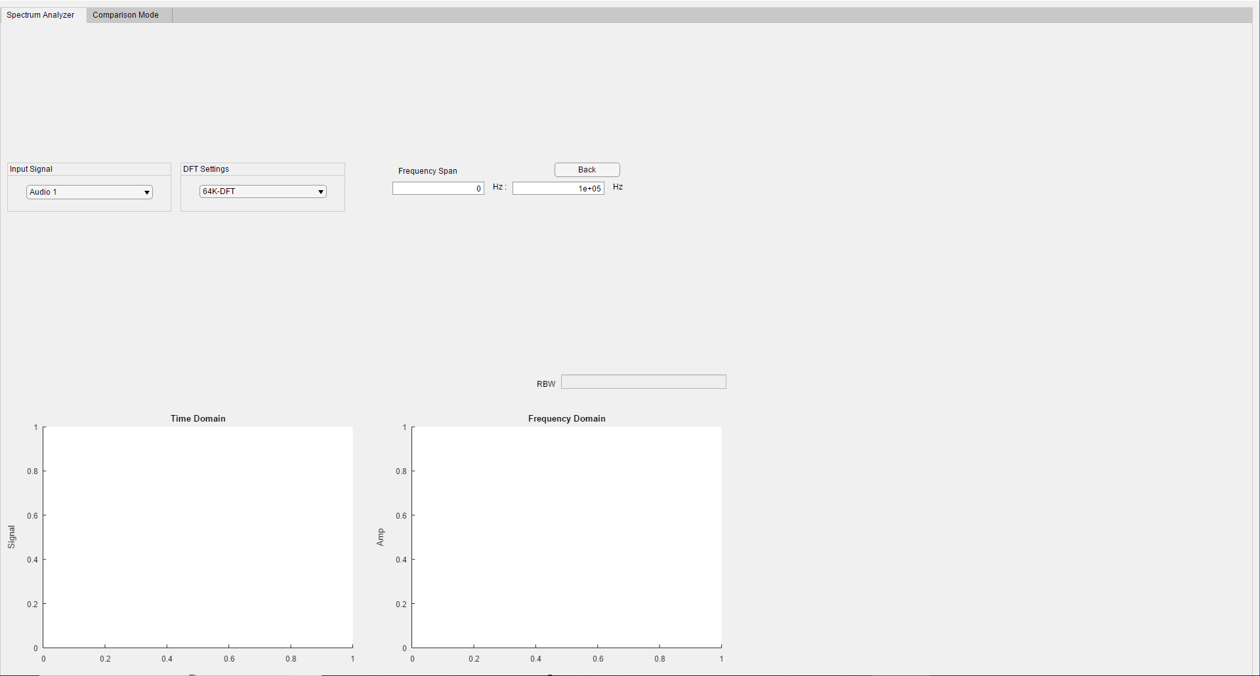

8

7

6

5

4

3

2

1

**Scale selection was implemented**

**Calculation mode was implemented**

1. Tab switch
2. Choosing the input signal
3. Choosing the desired DFT settings
4. Choosing the frequency span
5. Back button: takes you back to the opening window
6. Time domain graph representation of the input signal
7. Frequency domain graph representation of the input signal
8. RBW calculation (Resolution Bandwidth)

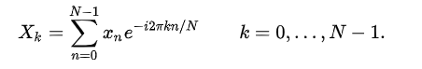

Comparison Mode tab

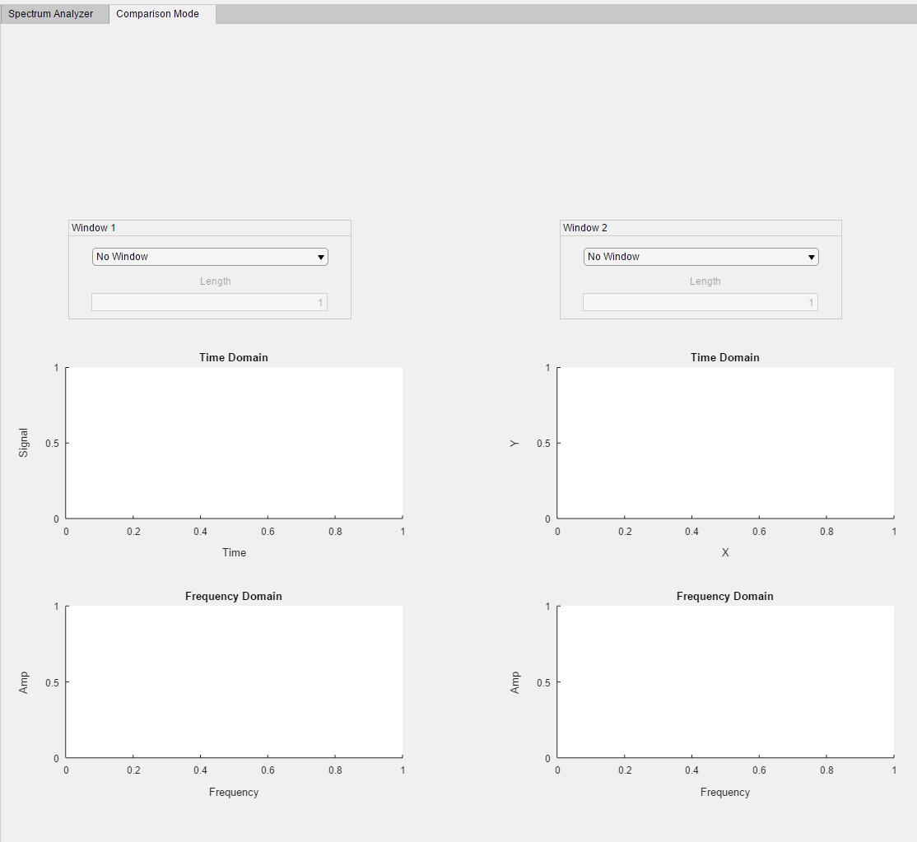

7

6

5

4

3

2

1

1. Tab switch
2. Window 1 selector: it allows user to select desired window and set its length with maximum value of signal length
3. Windowed Signal time domain graph representation
4. Windowed Signal frequency domain graph representation
5. Window 2 selector: it allows user to select desired window and set its length with maximum value of signal length
6. Windowed Signal time domain graph representation
7. Windowed Signal frequency domain graph representation

**Scale selection was implemented**

Note: this tab uses the same input signal entered in the spectrum analyzer tab. If the user tried this tab first without setting an input signal the controls will not respond.

$$X\left(n\right)=x\left(n\right) . w(n)$$

$$X\left(m\right)=x\left(m\right)*w(m)$$

**Filter Design Window**-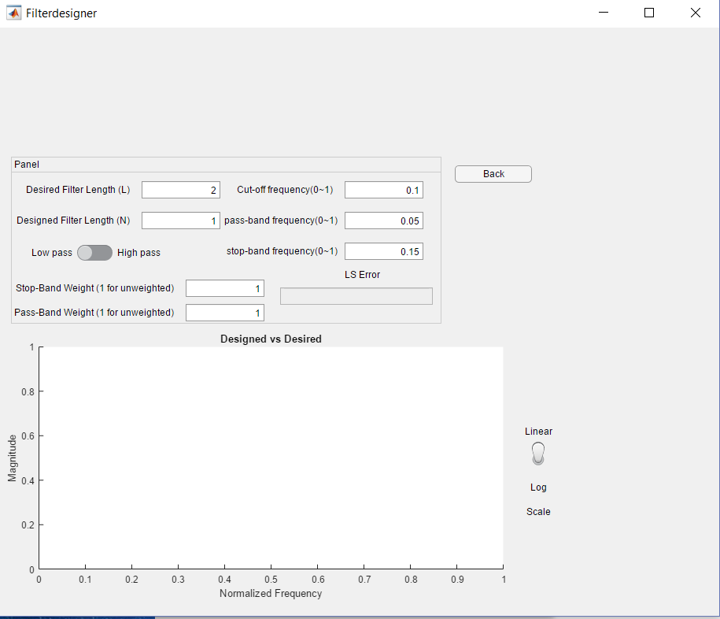

3

2

1

1- filter parameter settings

2- back button: takes you back to gate

3- Designed filter vs Desired filter graph

# Results, and Example

DFT convolution Example

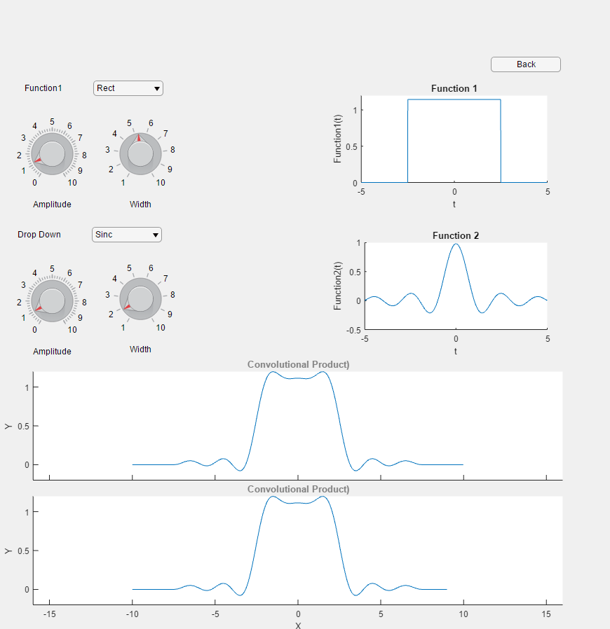

Spectrum Analyzer Example

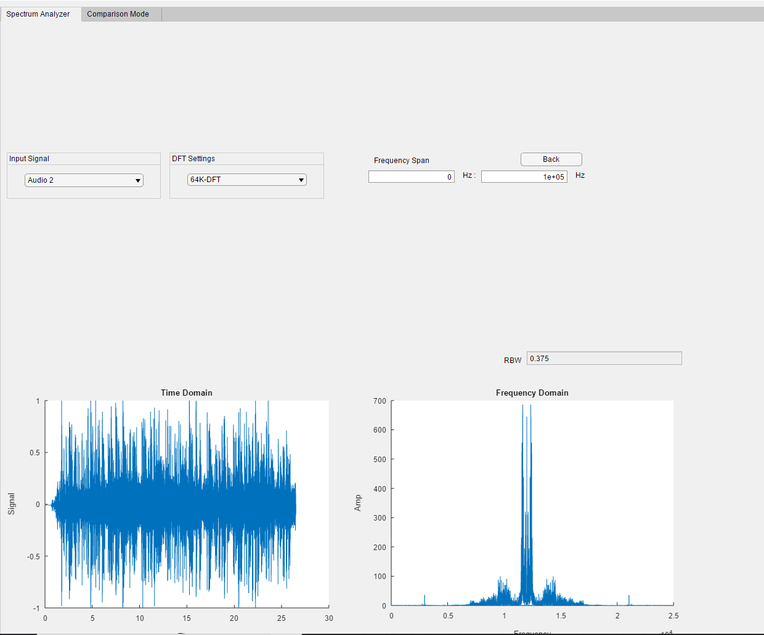

Comparison Mode Example

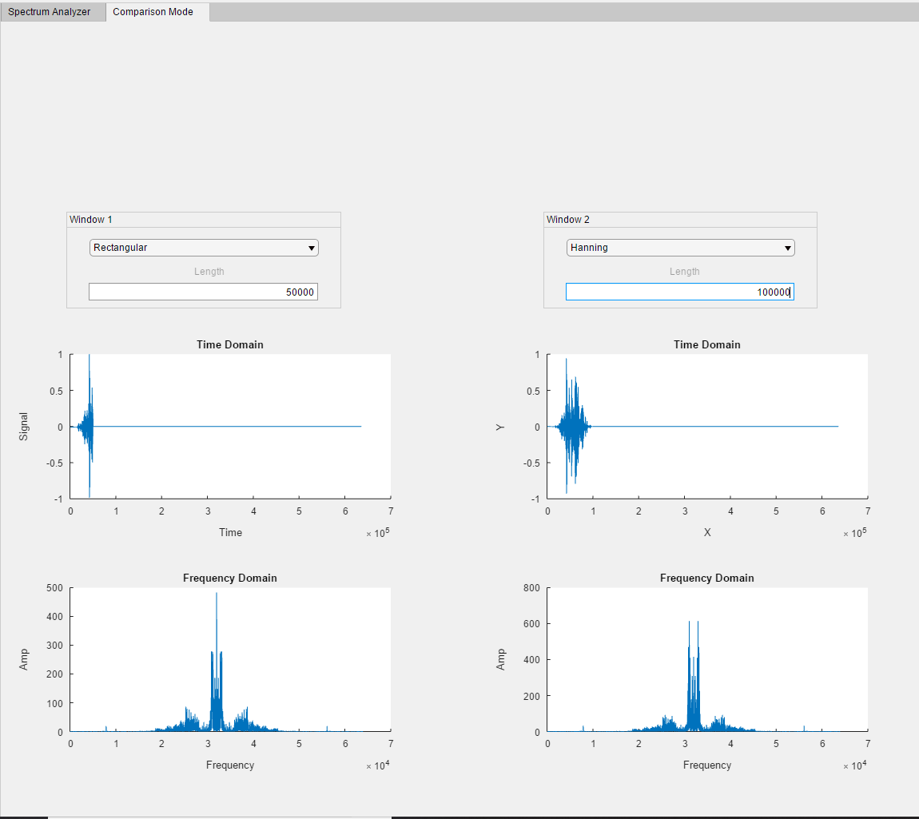

Filter Design Example

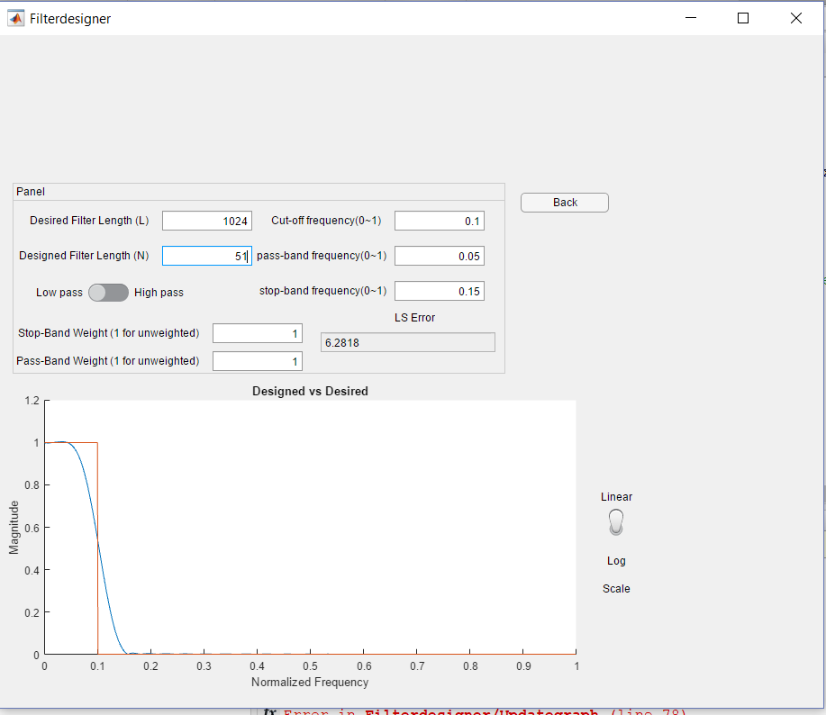

# References

<https://en.wikipedia.org/wiki/Convolution>

<https://en.wikipedia.org/wiki/Fast_Fourier_transform>

<https://en.wikipedia.org/wiki/Window_function>

<https://www.mathworks.com/help/signal/ug/discrete-fourier-transform.html>

<http://eeweb.poly.edu/iselesni/EL713/firls/firls.pdf>